Banking Risk Analytics Dashboard – Project Documentation

1. Project Overview

Project Title: Banking Risk Analytics Dashboard using Power BI & Python

Objective
To analyze and understand customer profiles in order to recommend the most suitable financial products based on their needs and behavior.
This project analyzes customer financial behavior, deposits, loans, and engagement metrics.

2. Business Problem Statement
Banks manage a diverse customer base with varying financial behaviors and needs. Understanding customer profiles in depth is essential to offer the right financial products at the right time. However, traditional analysis methods often fail to capture the complexity of customer income patterns, account activity, and product usage.
Problem:
How can banks leverage historical customer data to:
- Gain deeper insights into customer profiles
- Identify customer segments based on financial behaviour

3. Solution Approach
The solution adopts a data-driven approach using:
- Python (Jupyter Notebook) for data understanding, cleaning, preprocessing, and exploratory data analysis (EDA)
- Power BI for building interactive dashboards and key performance indicators (KPIs)

4. Dataset Description
The dataset contains historical banking customer data used to analyse customer profiles and financial behaviour. It consists of 3,000 customer records with 25 attributes, combining demographic, relationship, and financial information.
Key Data Categories
1. Customer Demographics
- Client ID, Name
- Age, Gender, Nationality
- Occupation, Location ID
2. Banking Relationship Information
- Date Joined Bank
- Banking Contact
- Fee Structure
- Loyalty Classification
- Engagement Duration (derived)
- Investment Advisor (IA)
- Banking Relationship (BR)
3. Financial & Account Details
- Estimated Income
- Superannuation Savings
- Credit Card Count and Balance
- Bank Loans
- Bank Deposits
- Checking Accounts
- Saving Accounts
- Foreign Currency Account
- Business Lending
- Properties Owned
4. Risk Indicators
- Risk Weighting

5. Data Preprocessing & Cleaning

5.1 Feature Engineering
1. Data Loading and Initial Inspection
- The dataset was loaded using Pandas from a CSV file.
- Initial exploration was performed using:
  - head() to preview records
  - shape() to understand dataset size
  - info() to inspect data types and null values
  - describe() to review statistical summaries of numerical features
This step ensured familiarity with the dataset structure, variable types, and value ranges.
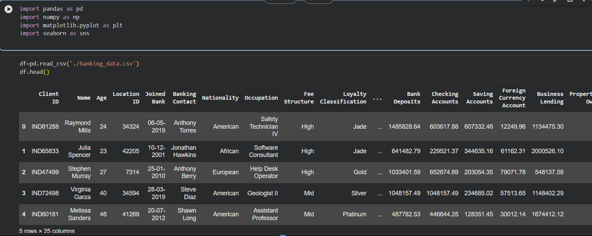
2. Feature Engineering – Income Band Creation
- A new derived column, Income Band, was created from the Estimated Income field.
- Income values were grouped into three categories:
  - Low
  - Mid
  - High
- This transformation enabled easier segmentation and comparison of customers across income levels in both analysis and Power BI dashboards.
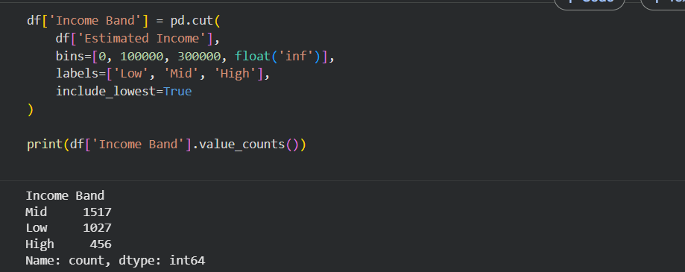
3. Categorical Data Review
- Key categorical variables such as:
  - Gender
  - Investment Advisor (IA)
  - Banking Relationship (BR)
  - Nationality
- were examined using value counts and count plots to understand customer distribution and dominance across categories.
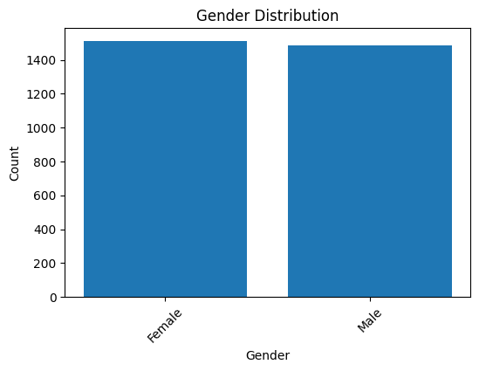
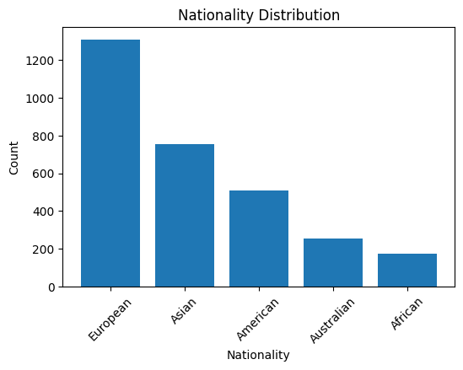
4. Numerical Data Preparation
- Core financial variables (income, savings, loans, deposits, account balances, and lending indicators) were retained in their numerical form.
- Distributions were analyzed using histograms to identify skewness, spread, and outliers.
- A correlation matrix was computed to understand relationships between major financial variables.
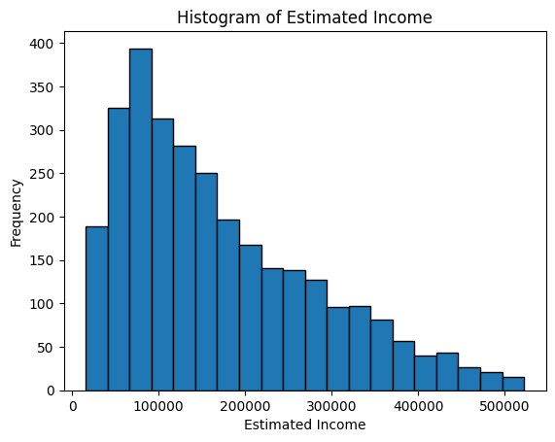
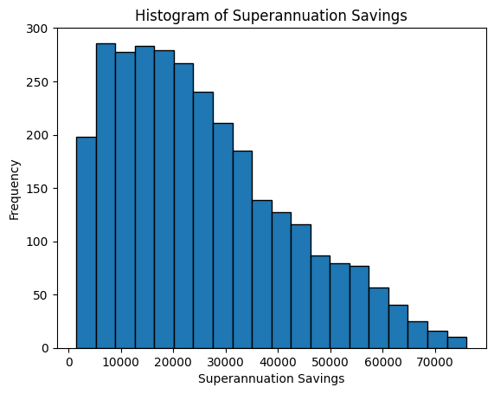

6. Key Performance Indicators (KPIs)

Core KPIs Implemented
- Total Clients – Number of unique banking customers
- Total Loan – Sum of all loan-related amounts
- Bank Loans – Personal loans taken by customers
- Business Lending – Loans issued to small businesses
- Total Deposits – Combined deposits across all account types
- Total Fees – Revenue generated via processing and service fees
- Credit Card Balance – Outstanding credit card dues

7. Dashboard & Visualizations

Dashboards Created

1. Home Dashboard
- Overall banking KPIs
- High-level customer distribution

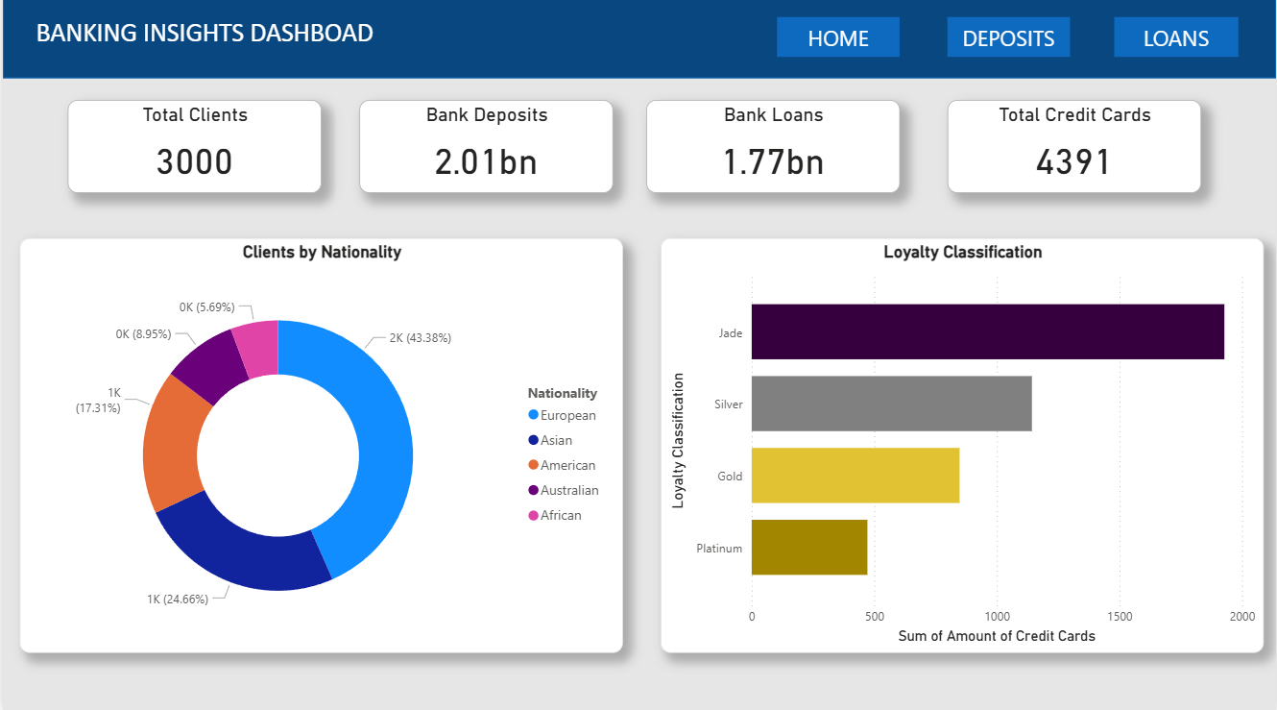

2. Loan Analysis Dashboard
- Loan amount by income band
- Loan distribution by gender and advisor

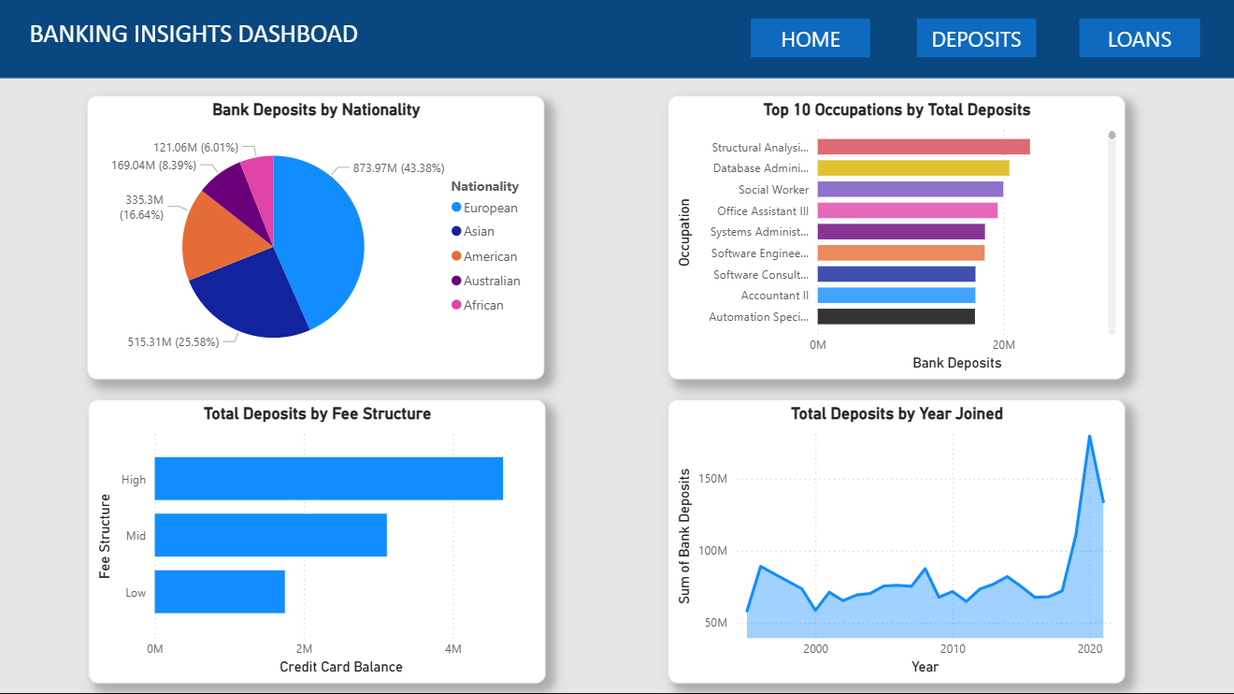

3. Deposit Analysis Dashboard
- Deposits by account type
- Customer contribution to total deposits

- 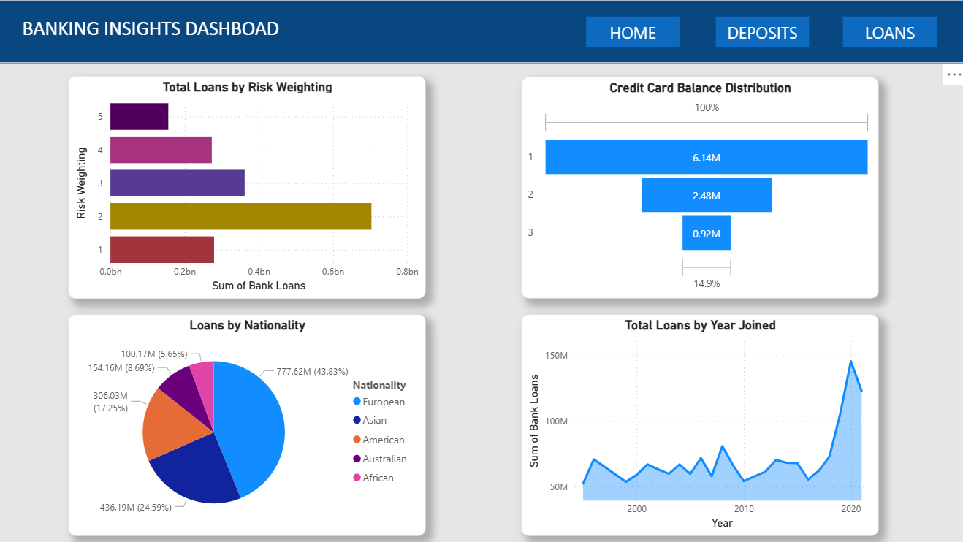

9. Insights & Results
1. High Activity Equals High Risk
The bank's "risk" rating measures financial activity and complexity, not likelihood of failure.
A higher risk score usually indicates a high-income customer with multiple accounts and large balances.
As clients earn more, their risk level rises naturally, reflecting more engagement with the bank and management of complex financial tools.
2. The "Full-Wallet" Effect
Successful customers both save and borrow heavily—they are not just choosing one strategy.
Clients with the largest savings and deposits also have the largest loans.
This suggests they leverage existing wealth to borrow for business or investment purposes, rather than out of cash shortage.
3. Success at Every Age
Age does not limit earnings or borrowing.
High incomes and large loans are found across all age groups, from young adults to retirees.
The bank’s clients are high performers at every life stage, with young professionals earning early and older clients maintaining wealth through smart investments.

12. Tools & Technologies Used
- Python (Pandas, NumPy, Matplotlib, Seaborn)
- Jupyter Notebook
- Power BI (DAX)
- Excel / CSV Data Sources

